1. INTRODUCTION

1.1 OVERVIEW

This involves estimating all the expenses required to start and operate the business, such as equipment, rent, inventory, and marketing. By calculating these costs upfront, business owners can better plan their budget and avoid unexpected expenses. Accurate expense estimation is vital for effective financial management and sustainable business growth.

WHAT ARE THE BENEFITS OF ESTIMATING BUSINESS EXPENSES?

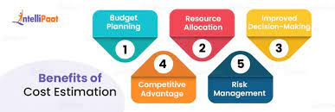

* Helps in creating a budget and forecasting future financial needs.
* Enables accurate tax preparation and helps in claiming detections.
* Facilitates comparing actual expenses to estimates for performance assessments.
* Overall, estimating expenses is a fundamental aspect of sound financial management for any business.

1.2 PURPOSE THE USES OF THIS PROJECT.

WHAT CAN BE ACHIEVED USING THIS?

Estimating expenses helps create a budget, allowing a business to allocate resources effectively and plan for financial obligations. Expense estimation allows for the calculation of projected profits, helping businesses gauge their financial viability and make informed decisions.

It assists in determining how much capital and resources are needed to sustain and grow the business. Estimating expenses helps in tax planning and ensures businesses set aside appropriate funds for tax obligations.

1.3 PROBLEM DEFINITION AND DESIGN THINKING

Empathy Map:

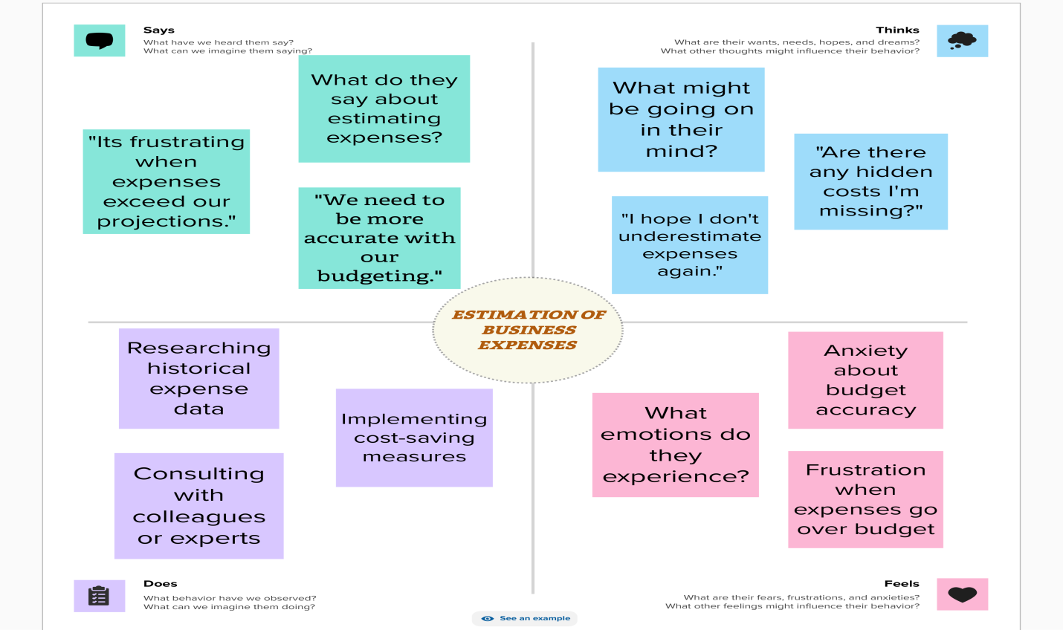

Ideation and Brainstorming Map:

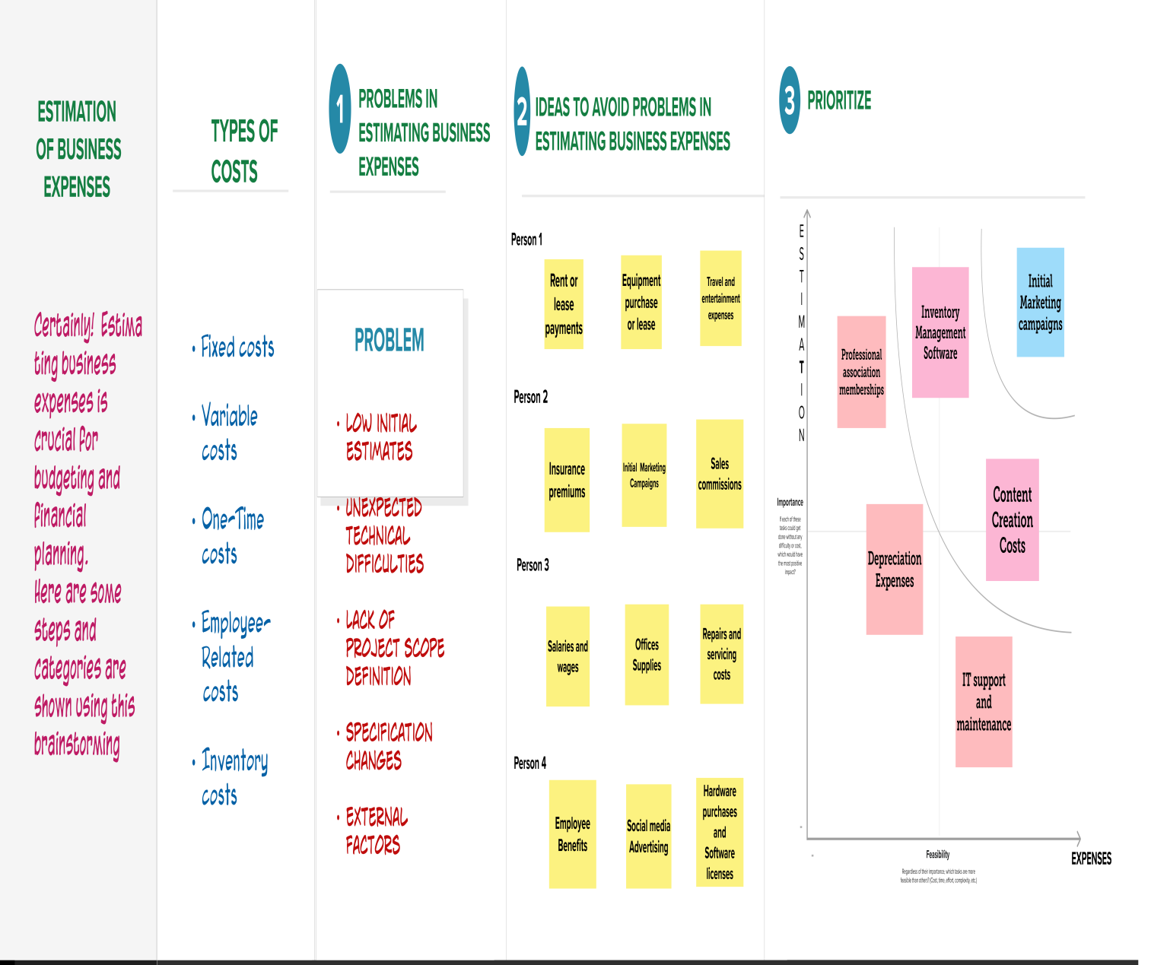

1.4 RESULT

Sheet 1:

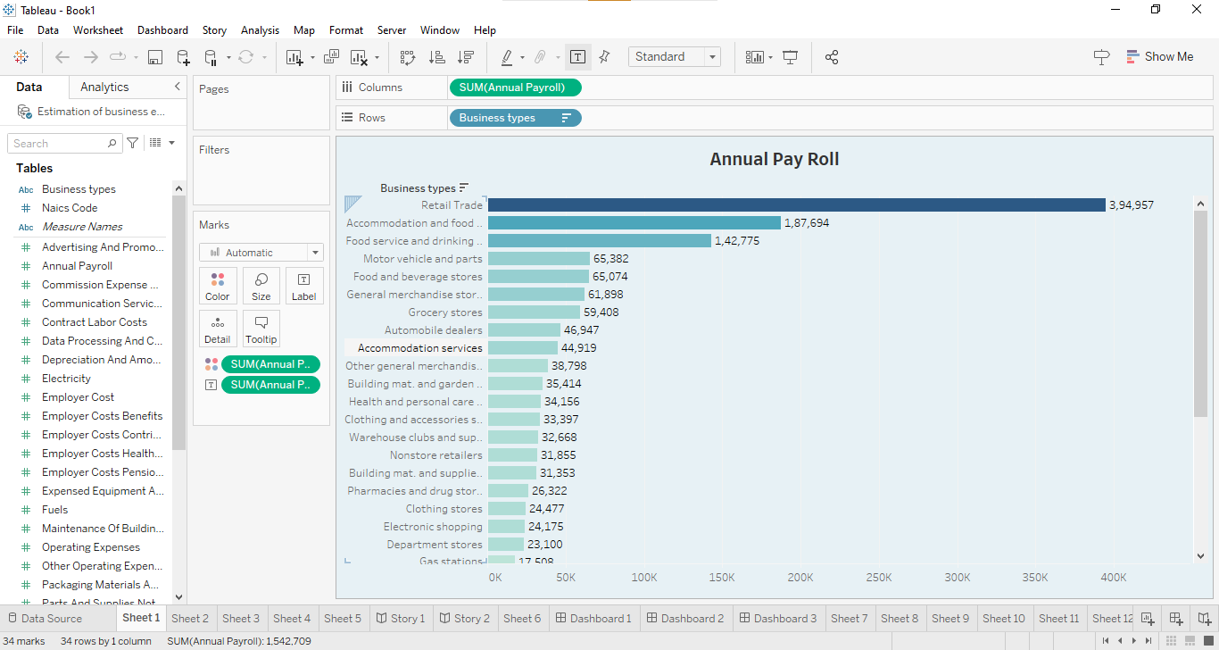

Sheet 2:

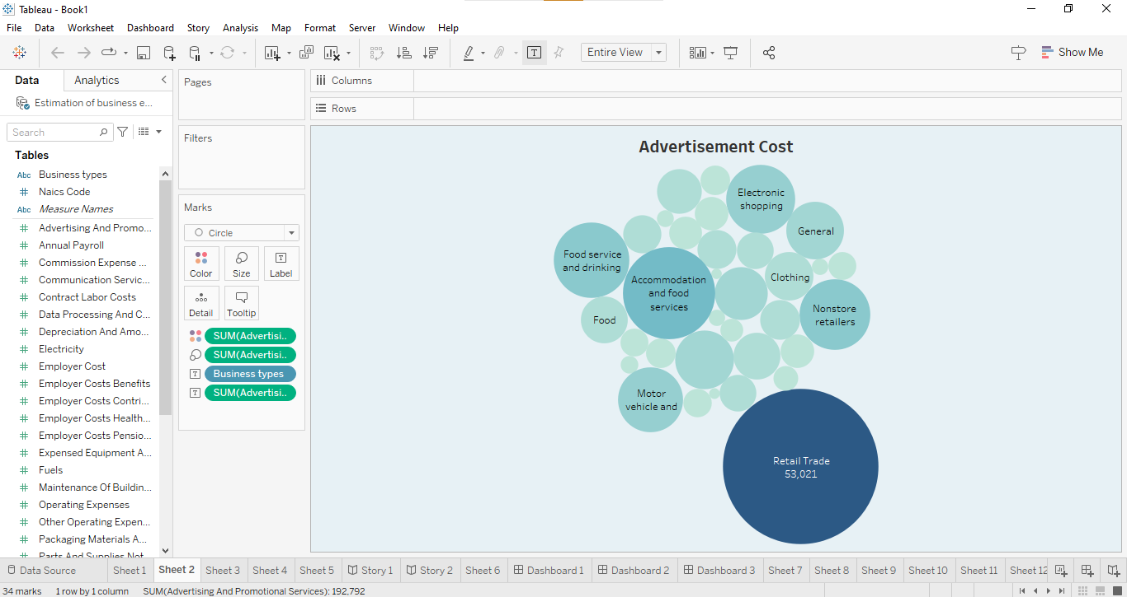

Sheet 3:

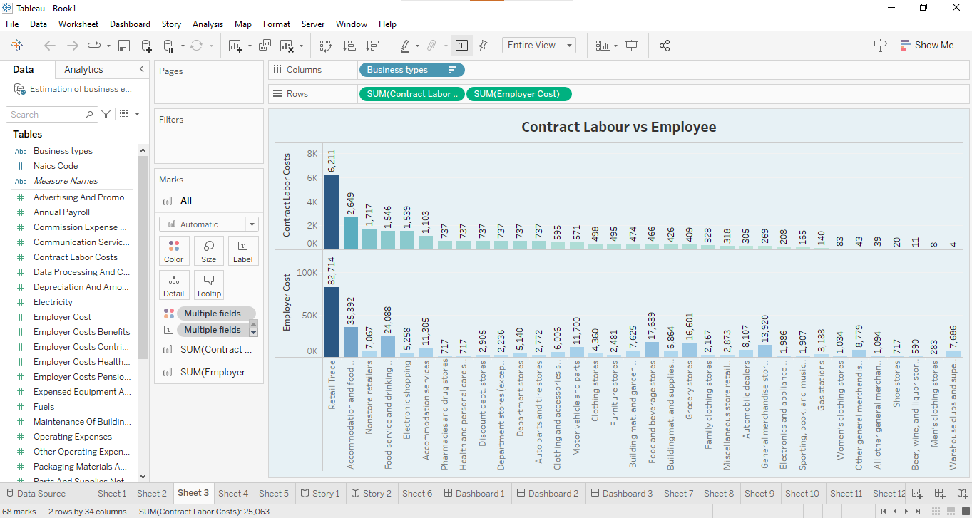

Sheet 4:

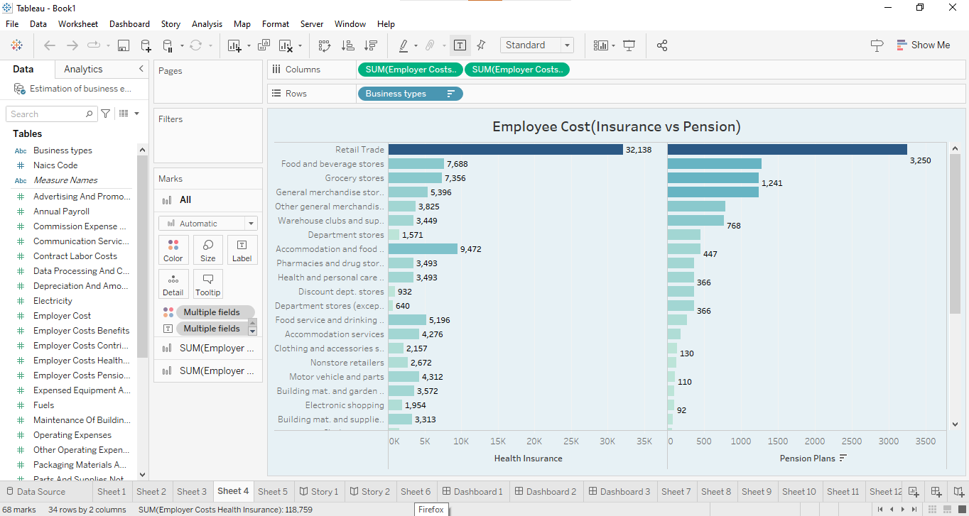

Sheet 5:

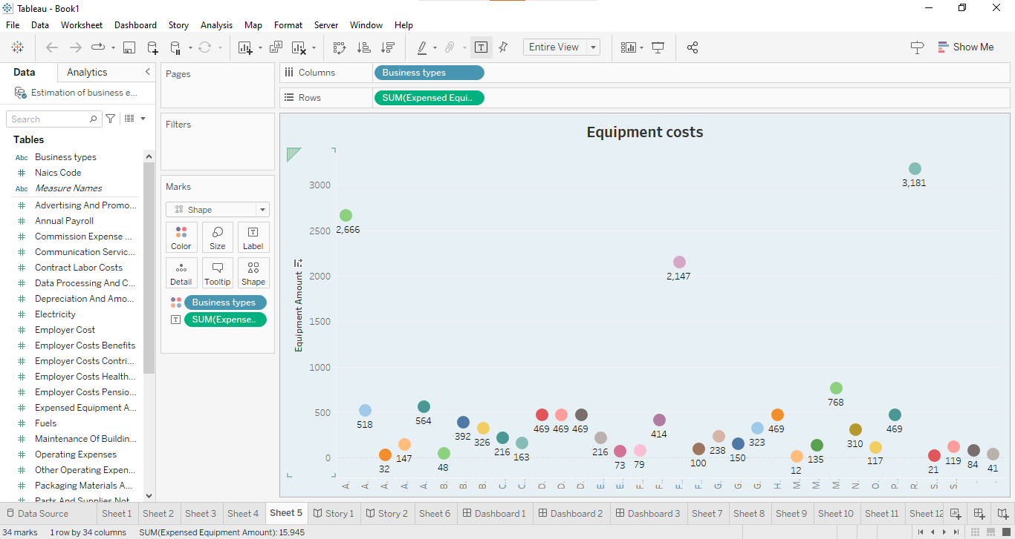

Sheet 6:

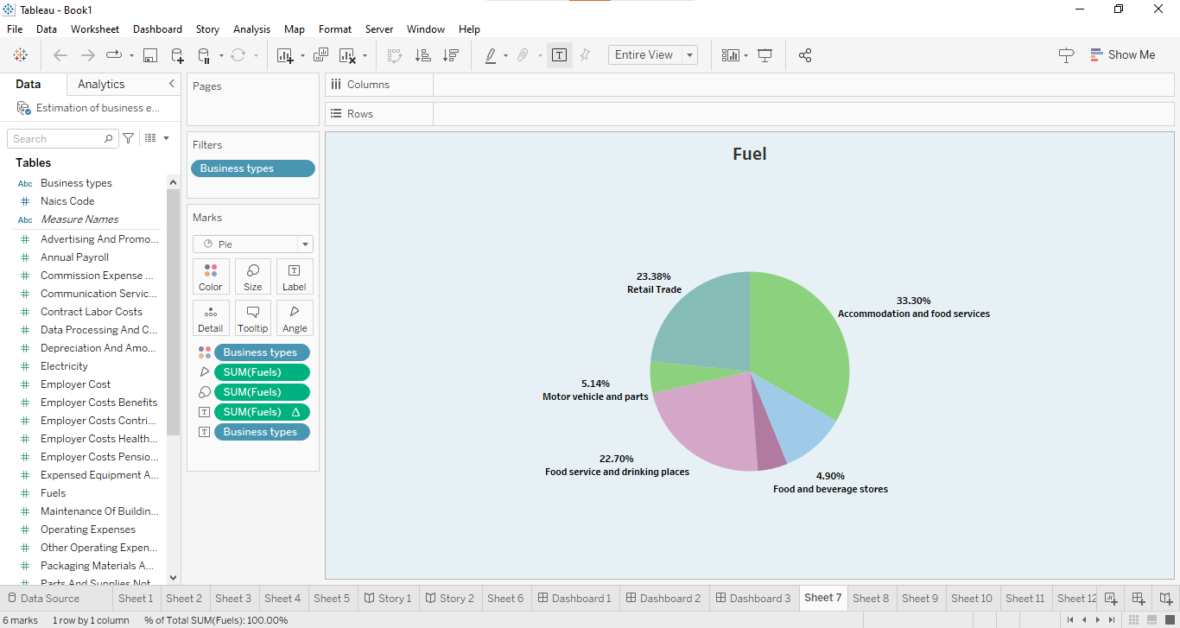

Sheet 7:

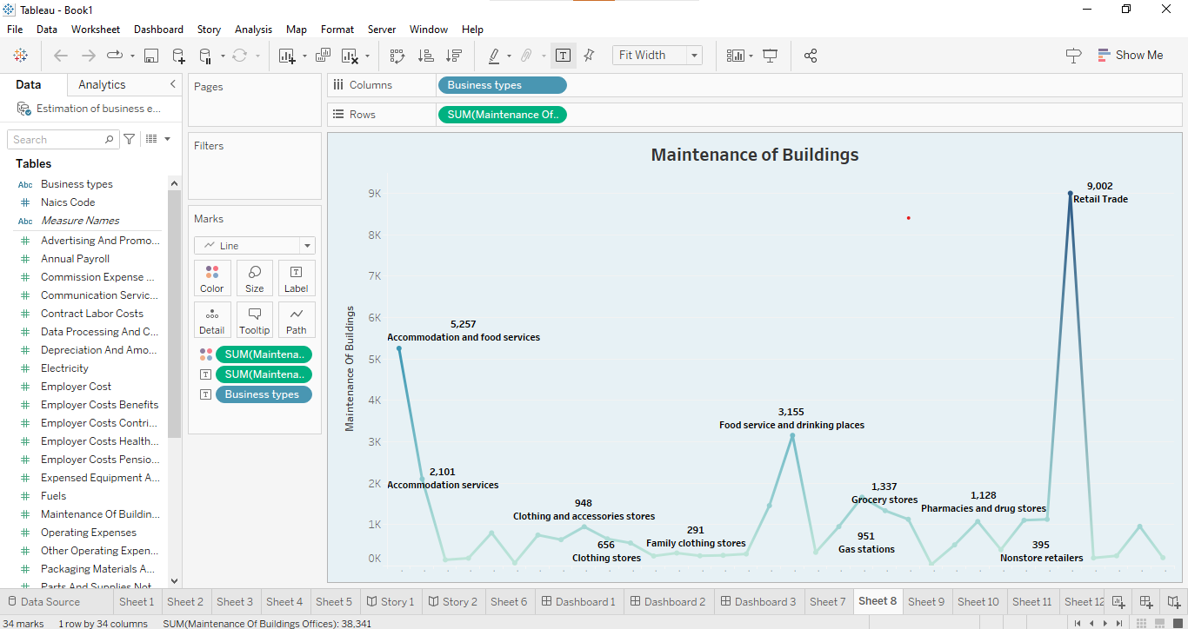

Sheet 8:

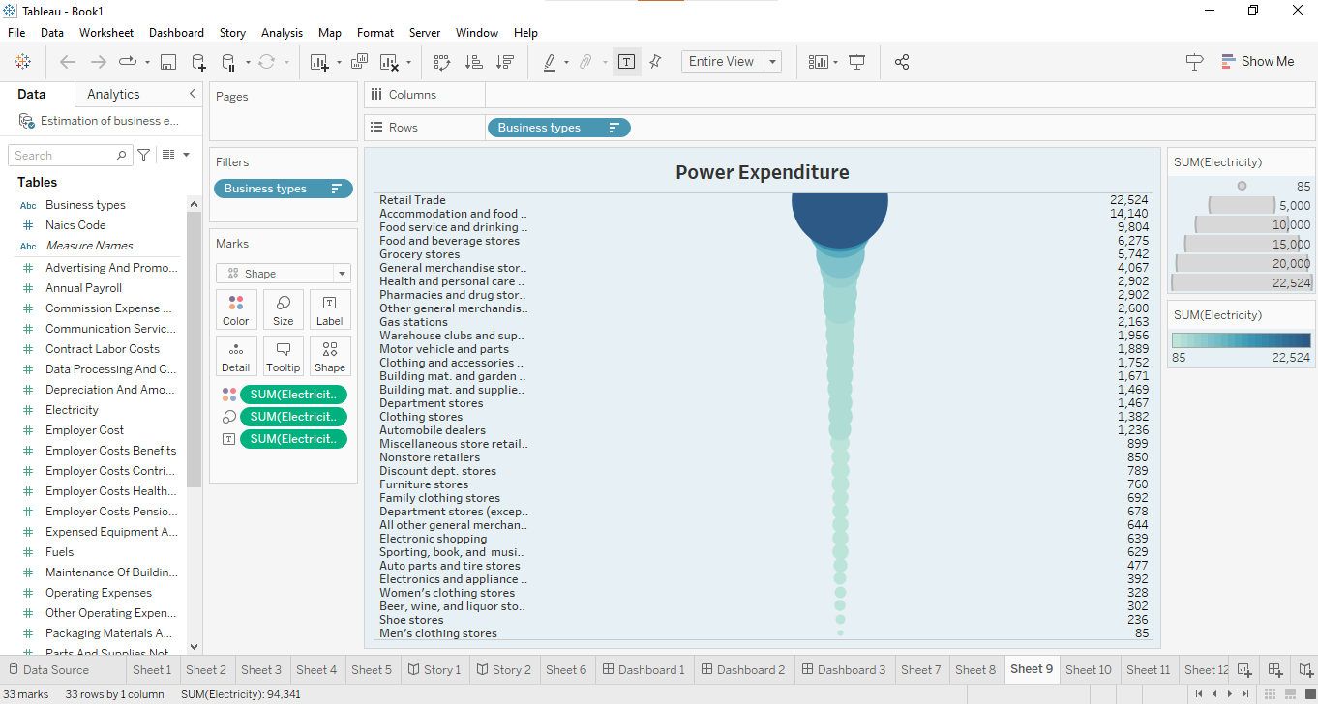

Sheet 9:

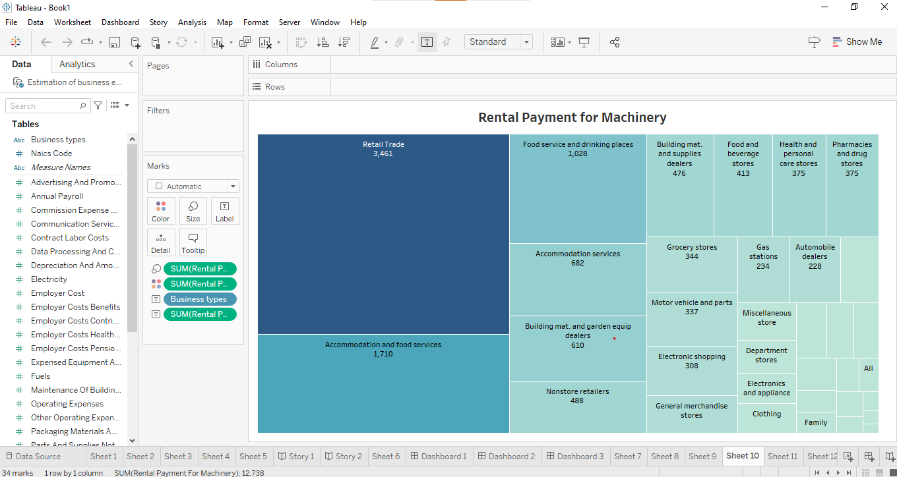

Sheet 10:

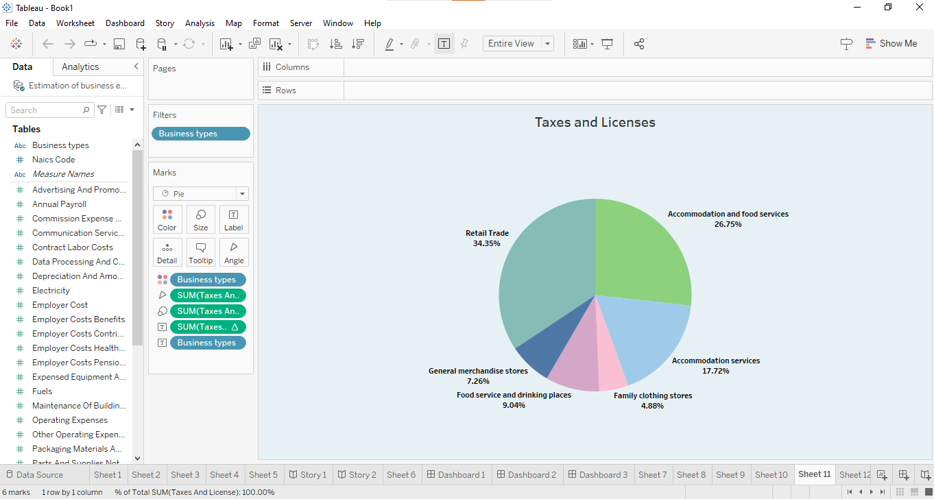

Sheet 11:

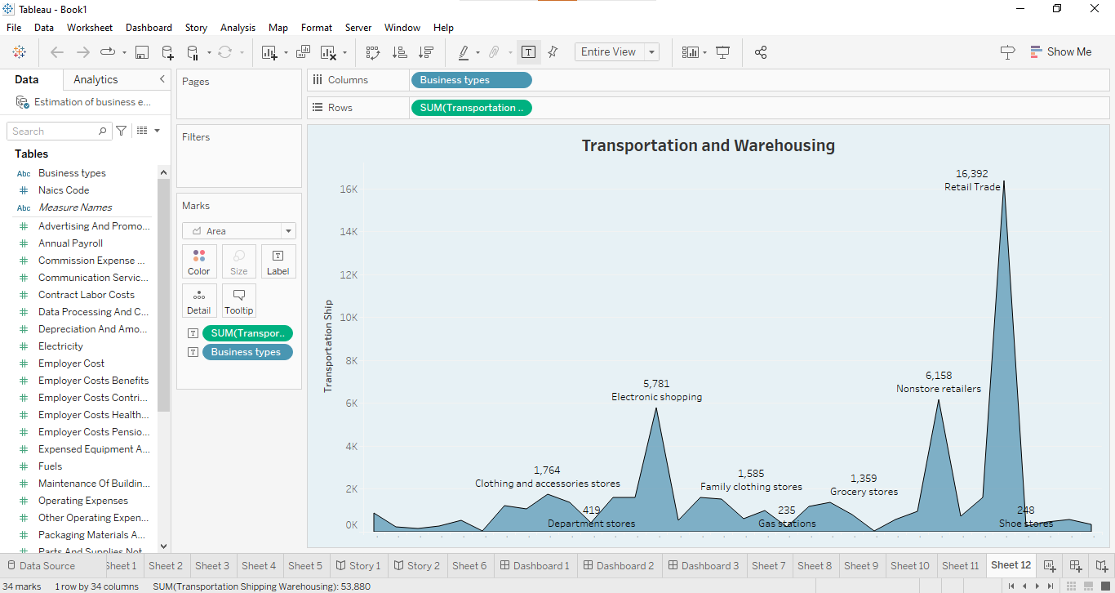

Dashboard 1:

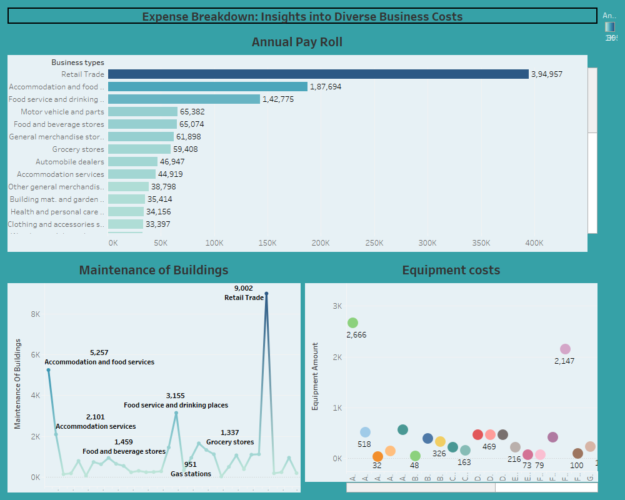

Dashboard 2:

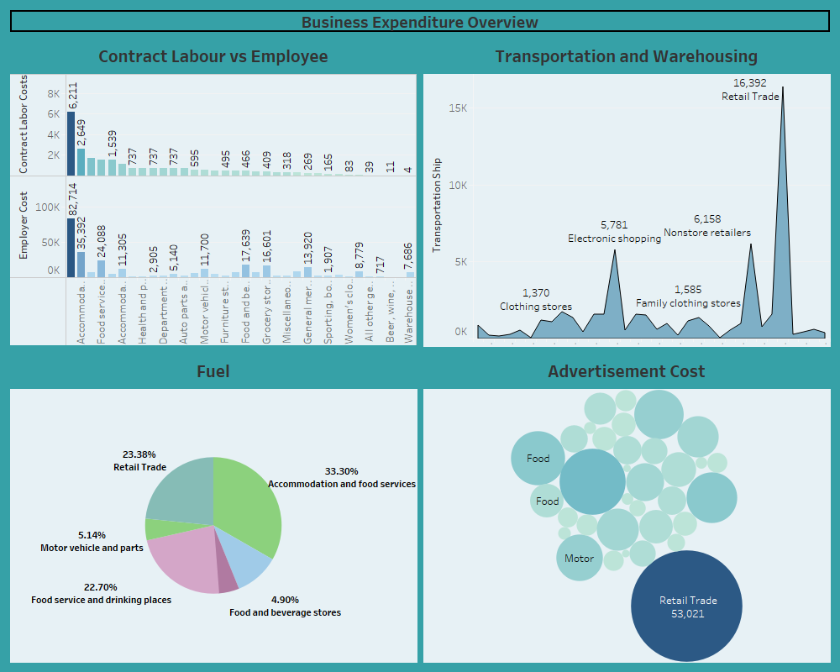

Dashboard 3:

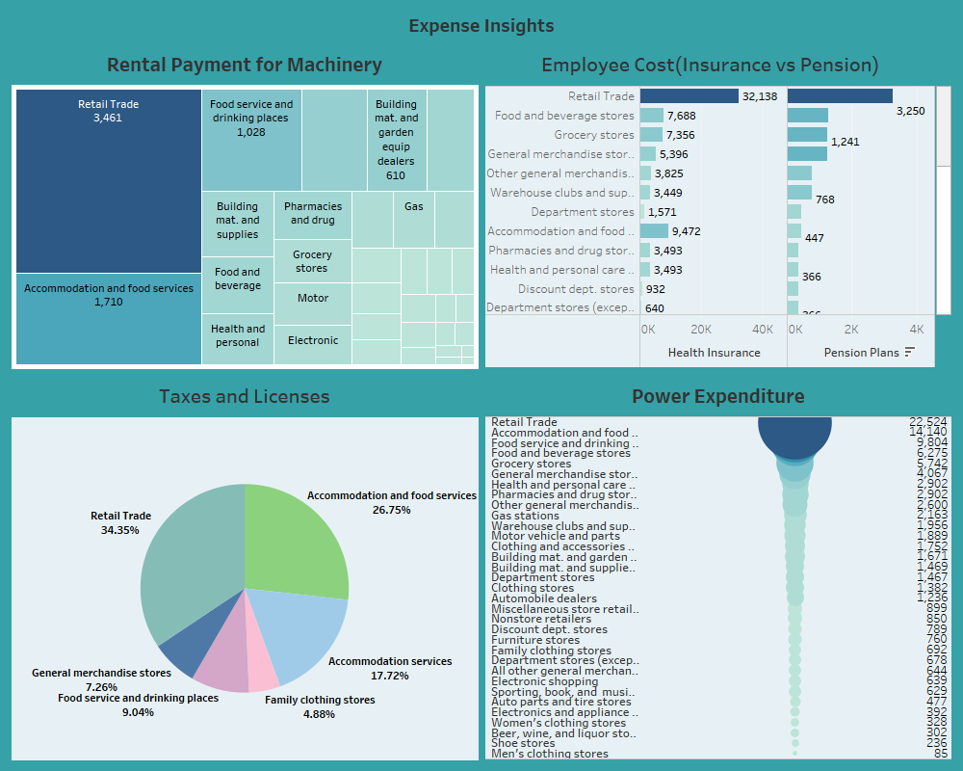

Story 1:

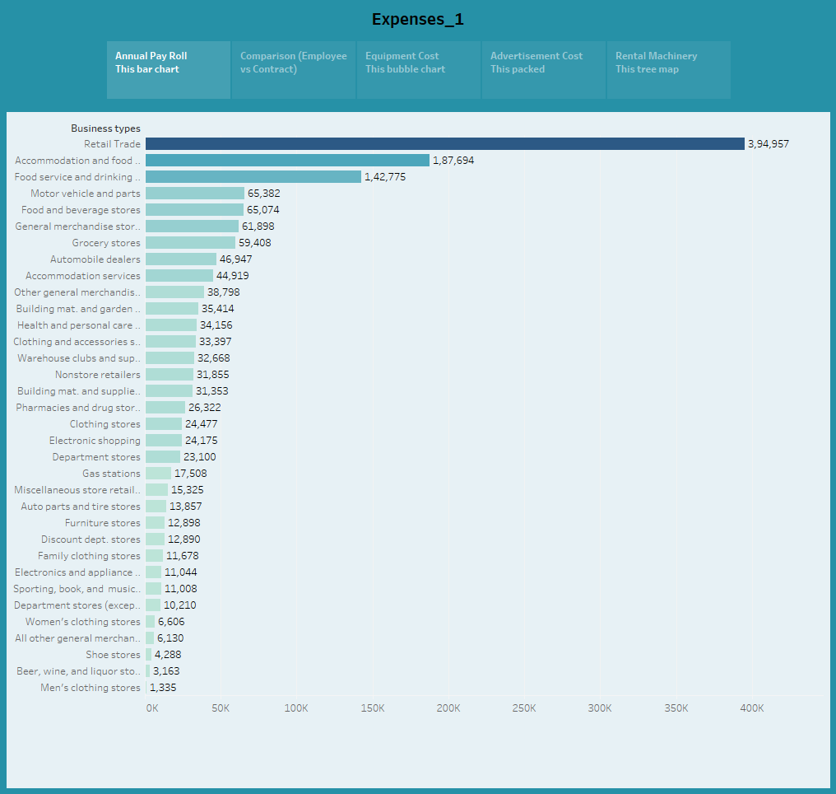

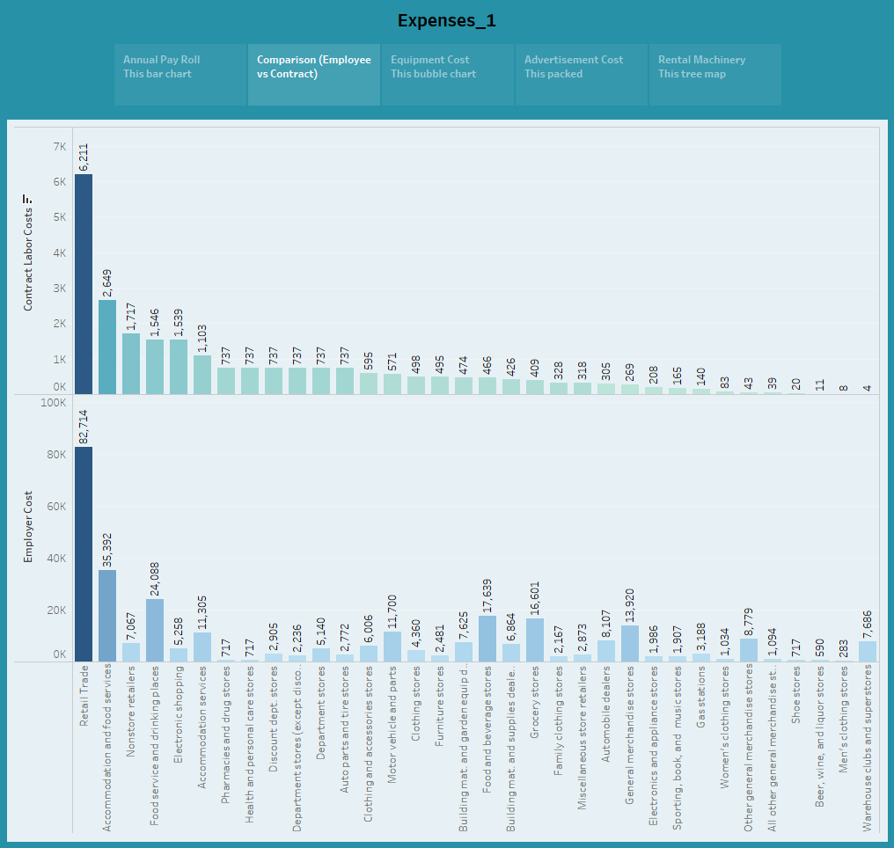

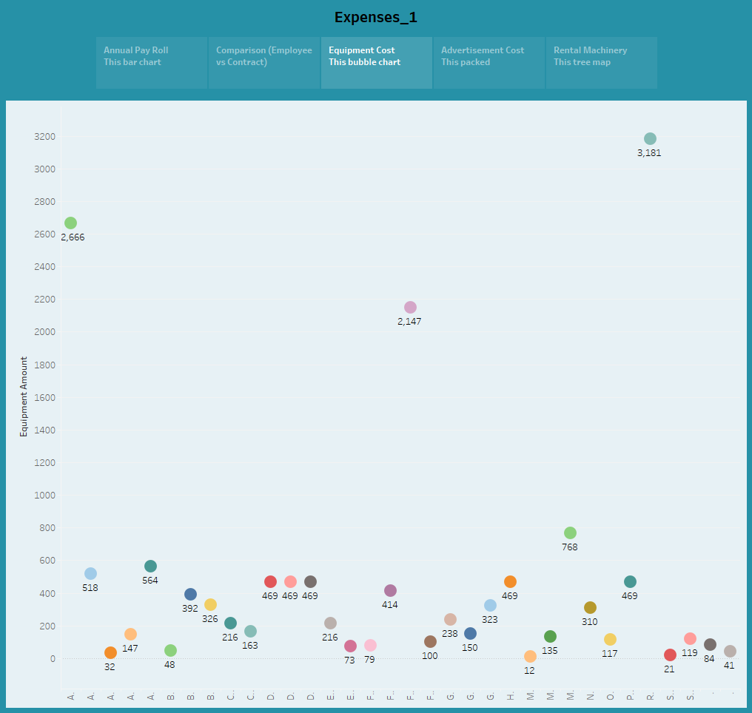

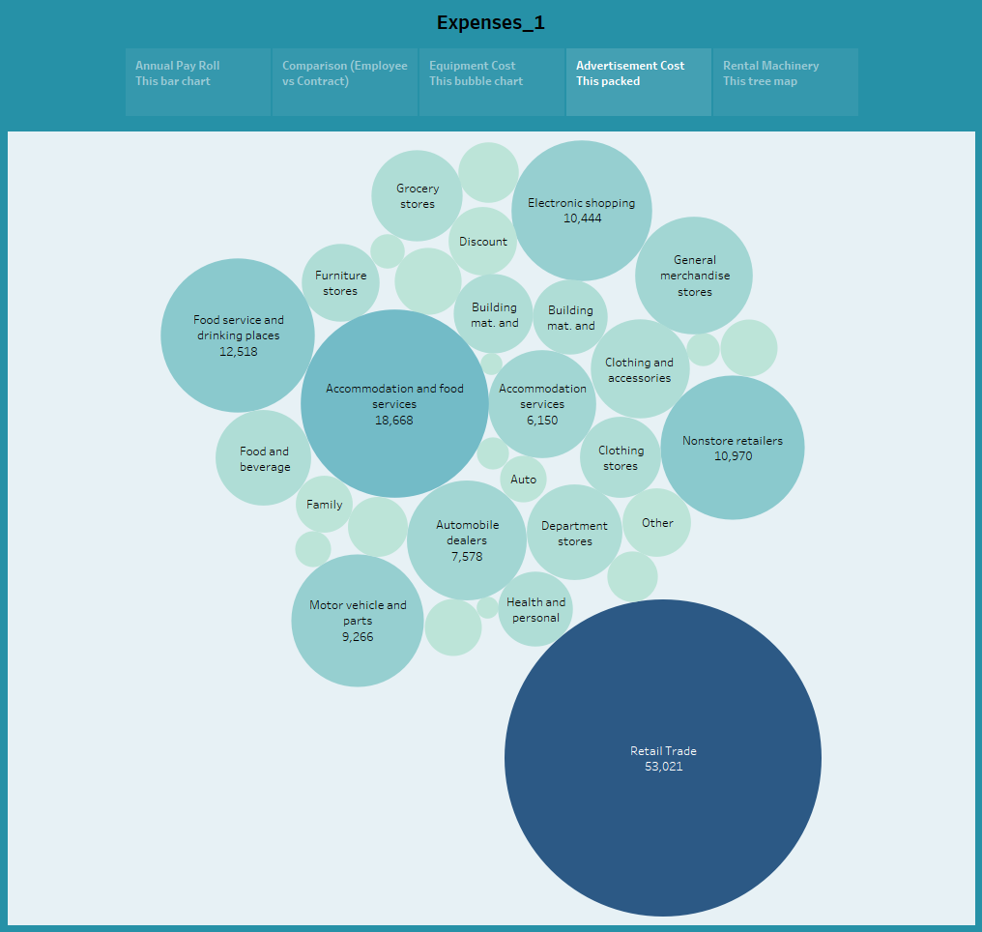

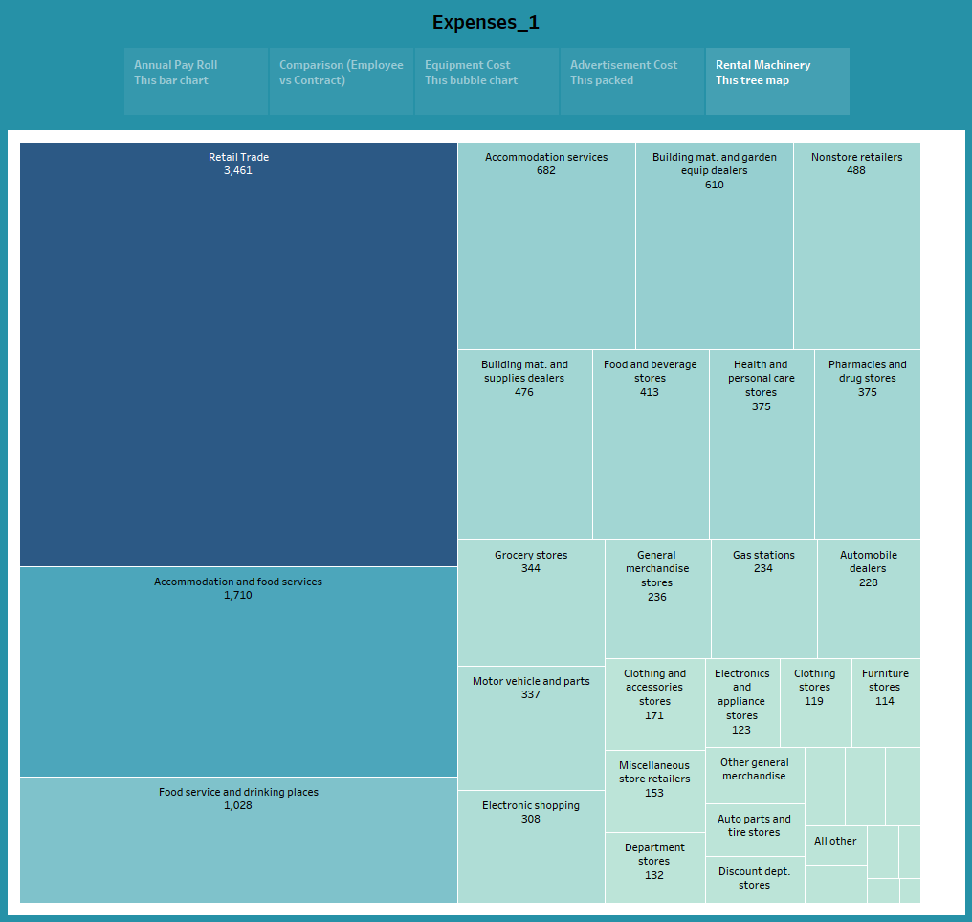

Story 2:

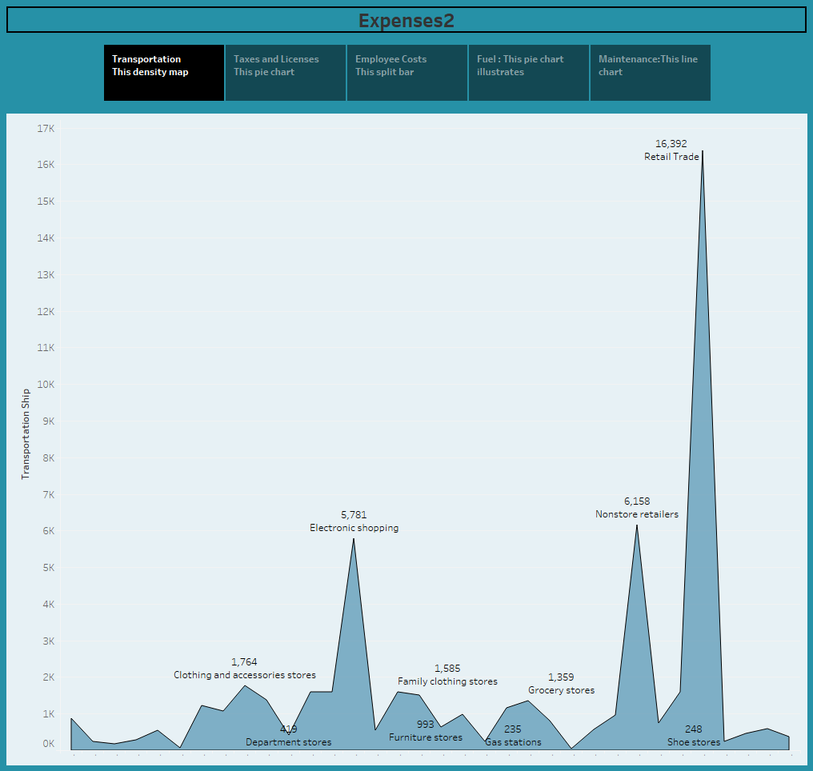

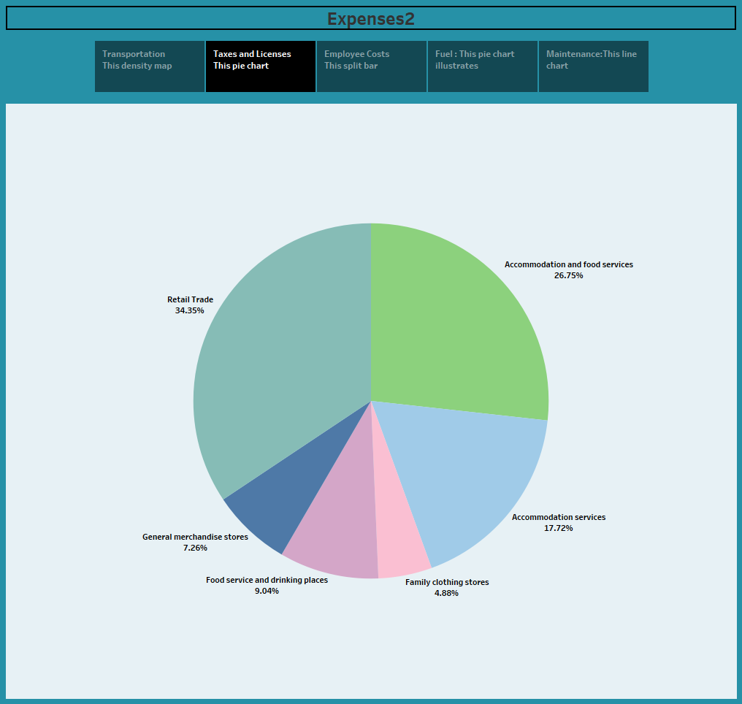

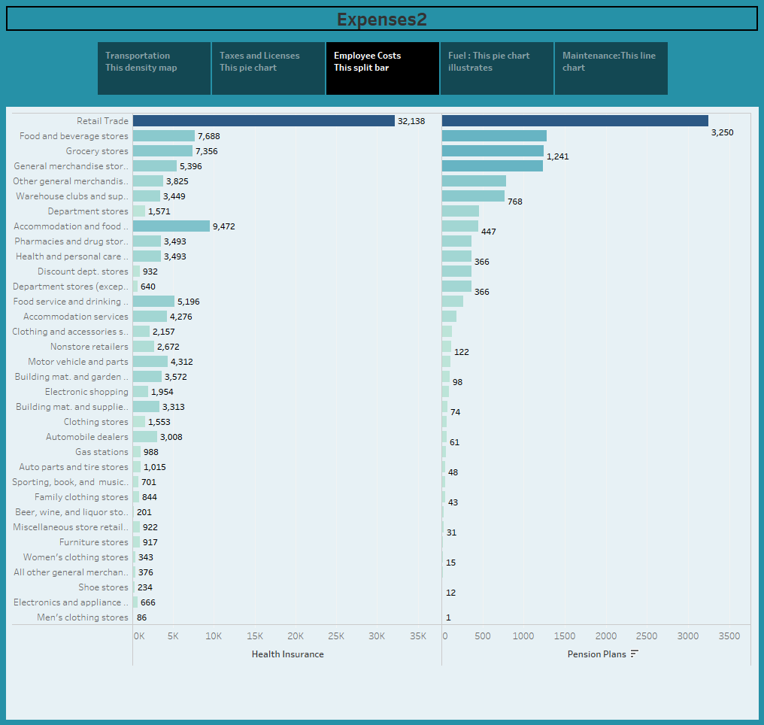

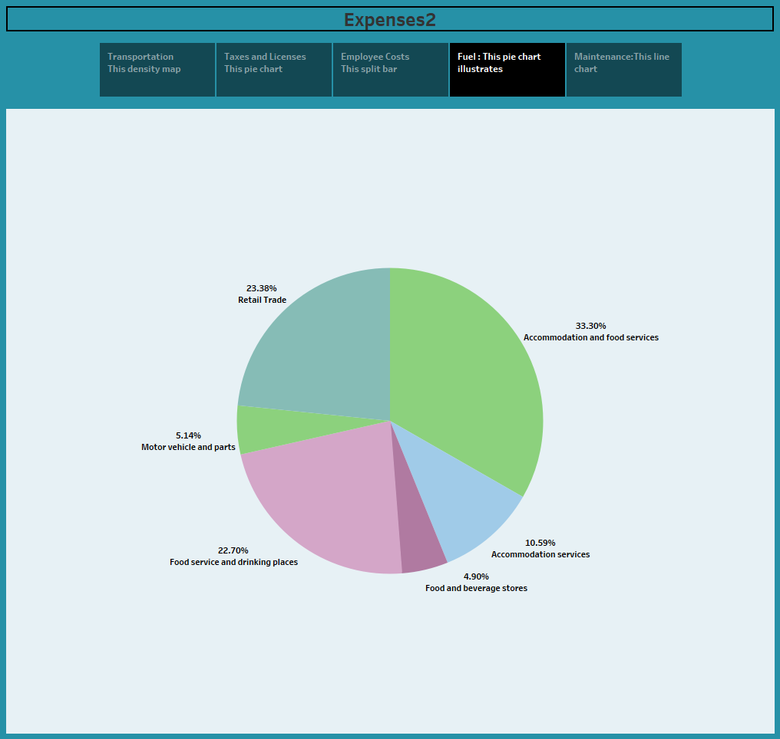

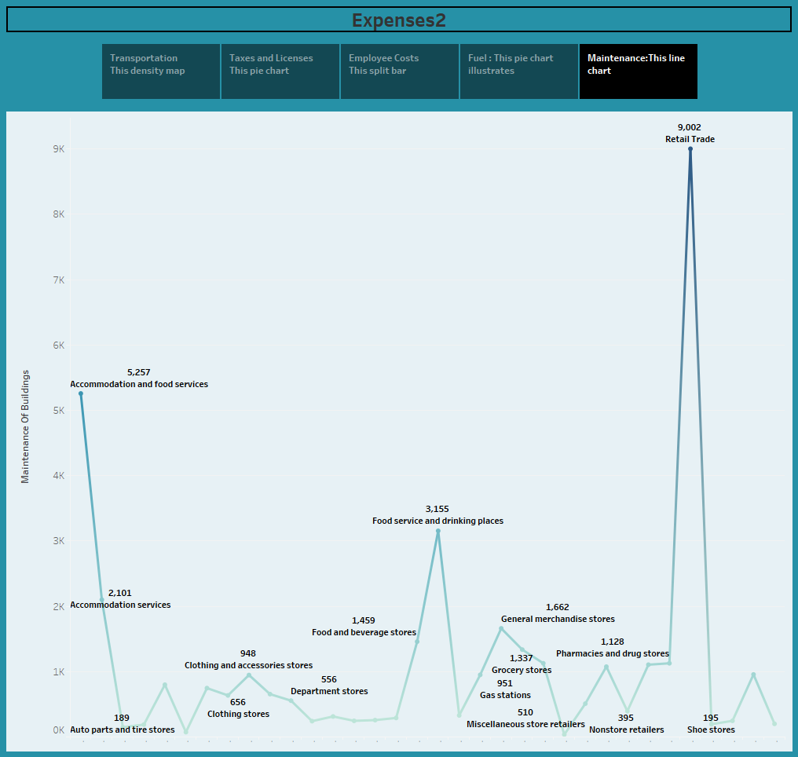

1.5. ADVANTAGES OF ESTIMATING BUSINESS EXPENSES

1. **Budgeting**: Estimating expenses helps create a budget, allowing a business to allocate resources effectively and plan for financial obligations.
2. **Financial Planning**: It aids in long –term financial planning by providing insights into expected costs and helping businesses set financial goals.
3. **Cost Control**: By estimating expenses, businesses can identify areas where cost control measures are needed and take pro active steps to manage spending.
4. **Profitability analysis**: Expense estimation allows for the calculation of projected profits, helping businesses gauge their financial viability and make informed decisions.
5. **Resource Allocation**: It assists in determining how much capital and resources are needed to sustain and grow the business.
6. **Tax planning**: Estimating expenses helps in tax planning and ensures businesses set aside appropriate funds for tax obligations.
7. **Adaptability**: As conditions change, expense estimation allows for timely adjustments to the budget and financial strategy.
8. **Investor confidence**: Accurate expense estimates build investor confidence by demonstrating financial stability.

1.6. DISADVANTAGES OF ESTIMATING BUSINESS EXPENSES

1. **Inaccuracy:** Estimates are inherently uncertain and may not always reflect actual expenses accurately. This can lead to budgeting shortfalls or overspending.
2. **Overly conservative estimates:** Businesses may tend to overestimate expenses to ensure they have enough funds, potentially leading to underinvestment in growth opportunities.
3. **Underestimation:** Conversely, underestimating expenses can result in financial challenges, such as cash flow problems or unexpected debt.
4. **Resource Misallocation:** Relying solely on estimates can lead to misallocation of resources, as budgets may not align with actual needs.
5. **Risk of Overlooked expenses:** It is possible to miscertain expenses or underestimate their impact, leading to financial surprises.
6. **Dependency on Data:** Accurate estimates depend on the quality of historical data and market research which may not always be available or reliable.
7. **Opportunity cost:** Being overly focused on expense management can lead to missed growth opportunities or innovation investments.

1.7. APPLICATION

* Estimations form the foundation of creating a budget, enabling businesses to allocate resources effectively and set financial targets. Estimating expenses helps in long- term financial planning, allowing businesses to anticipate cash flow needs and prepare for financial challenges.
* It aids in allocating funds, personnel, and other resources to different departments or projects within the organization. By forecasting expenses, businesses can identify areas where cost –saving measures can be implemented to improve profitability.

1.8. CONCLUSION:

Estimating business expenses is a fundamental practice that serves as the cornerstone of effective financial management and strategic decision-making for businesses.

FUTURE SCOPE

* The future scope of estimating business expenses is likely to evolve with advancements in technology and changing business landscapes.